Securing Lora by generating certificates

Configuration to generate certificates for the [LoRa Server](https://docs.loraserver.io/) project :

### Go installation

tar -C /usr/local -xzf go$VERSION.$OS-$ARCH.tar.gz

export PATH=$PATH:/usr/local/go/bin

### CFSSL installation

For generating the certificates, [cfssl](https://github.com/cloudflare/cfssl) is being used

go get -u github.com/cloudflare/cfssl/cmd/cfssl

go get -u github.com/cloudflare/cfssl/cmd/cfssljson

go get -u github.com/cloudflare/cfssl/cmd/...

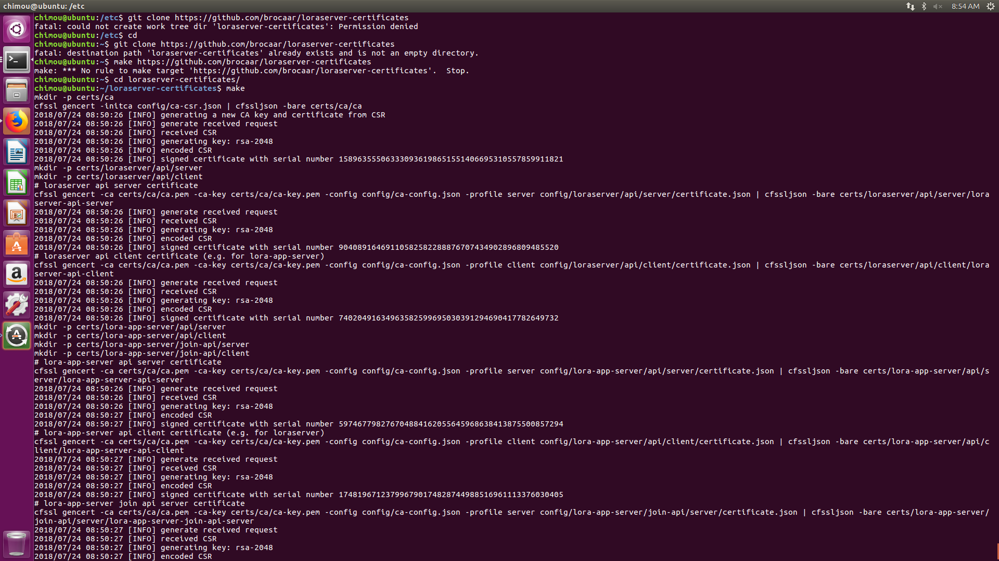

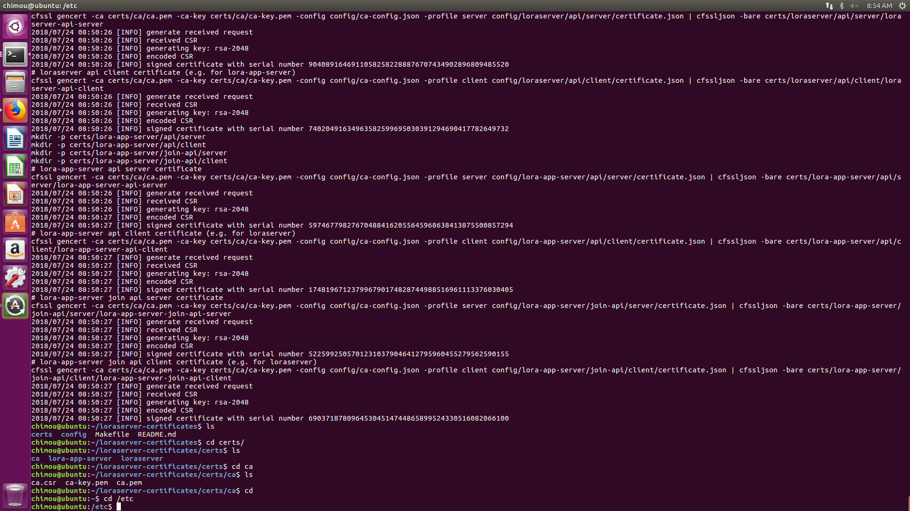



LoRa Server

LoRa Server is an open-source network-server, part of the LoRa Server project

 Configuration file : loraserver.toml

(ajout des certifs générés + modification des ports +génération de bytes aléatoires pour le jwt_secret)

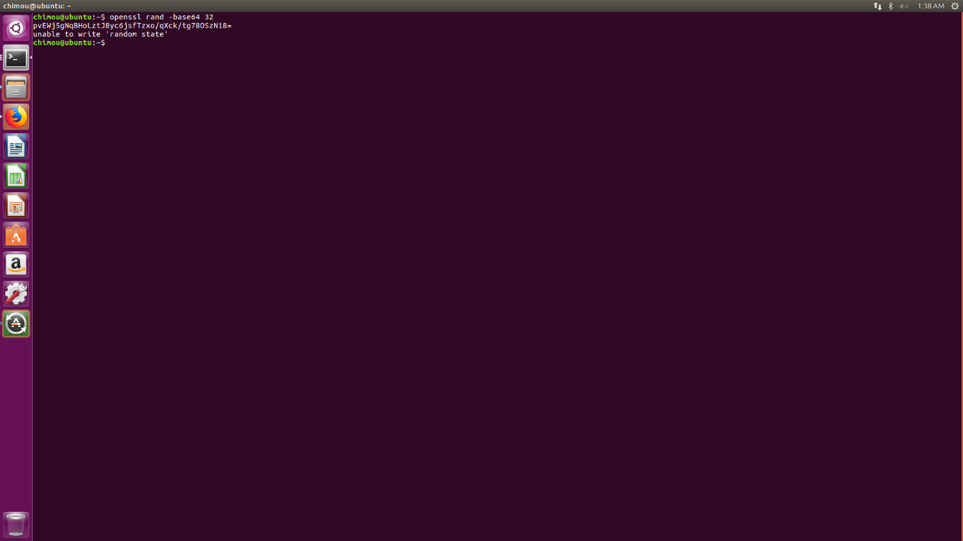

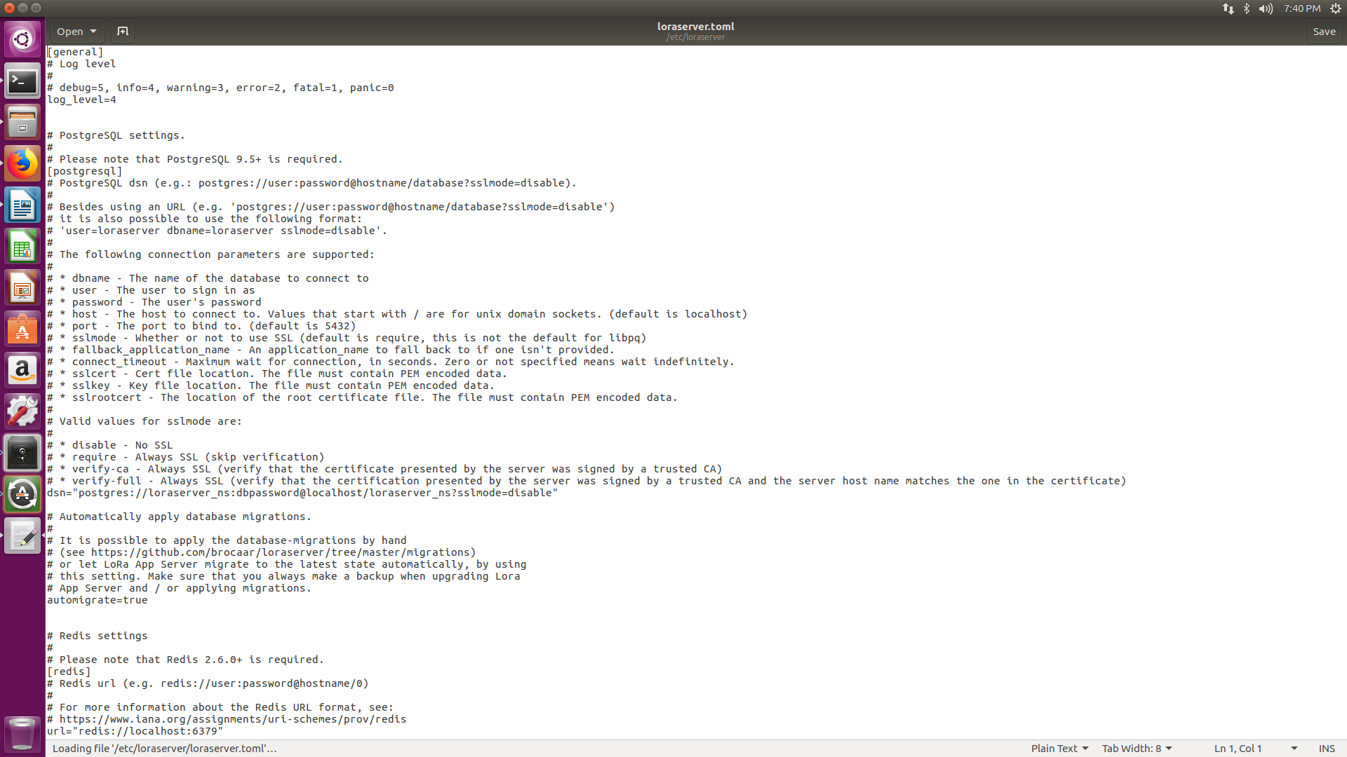

LoRa App Server

LoRa App Server is an open-source application-server, part of the LoRa Server project

## Configuration file : lora-app-server.toml

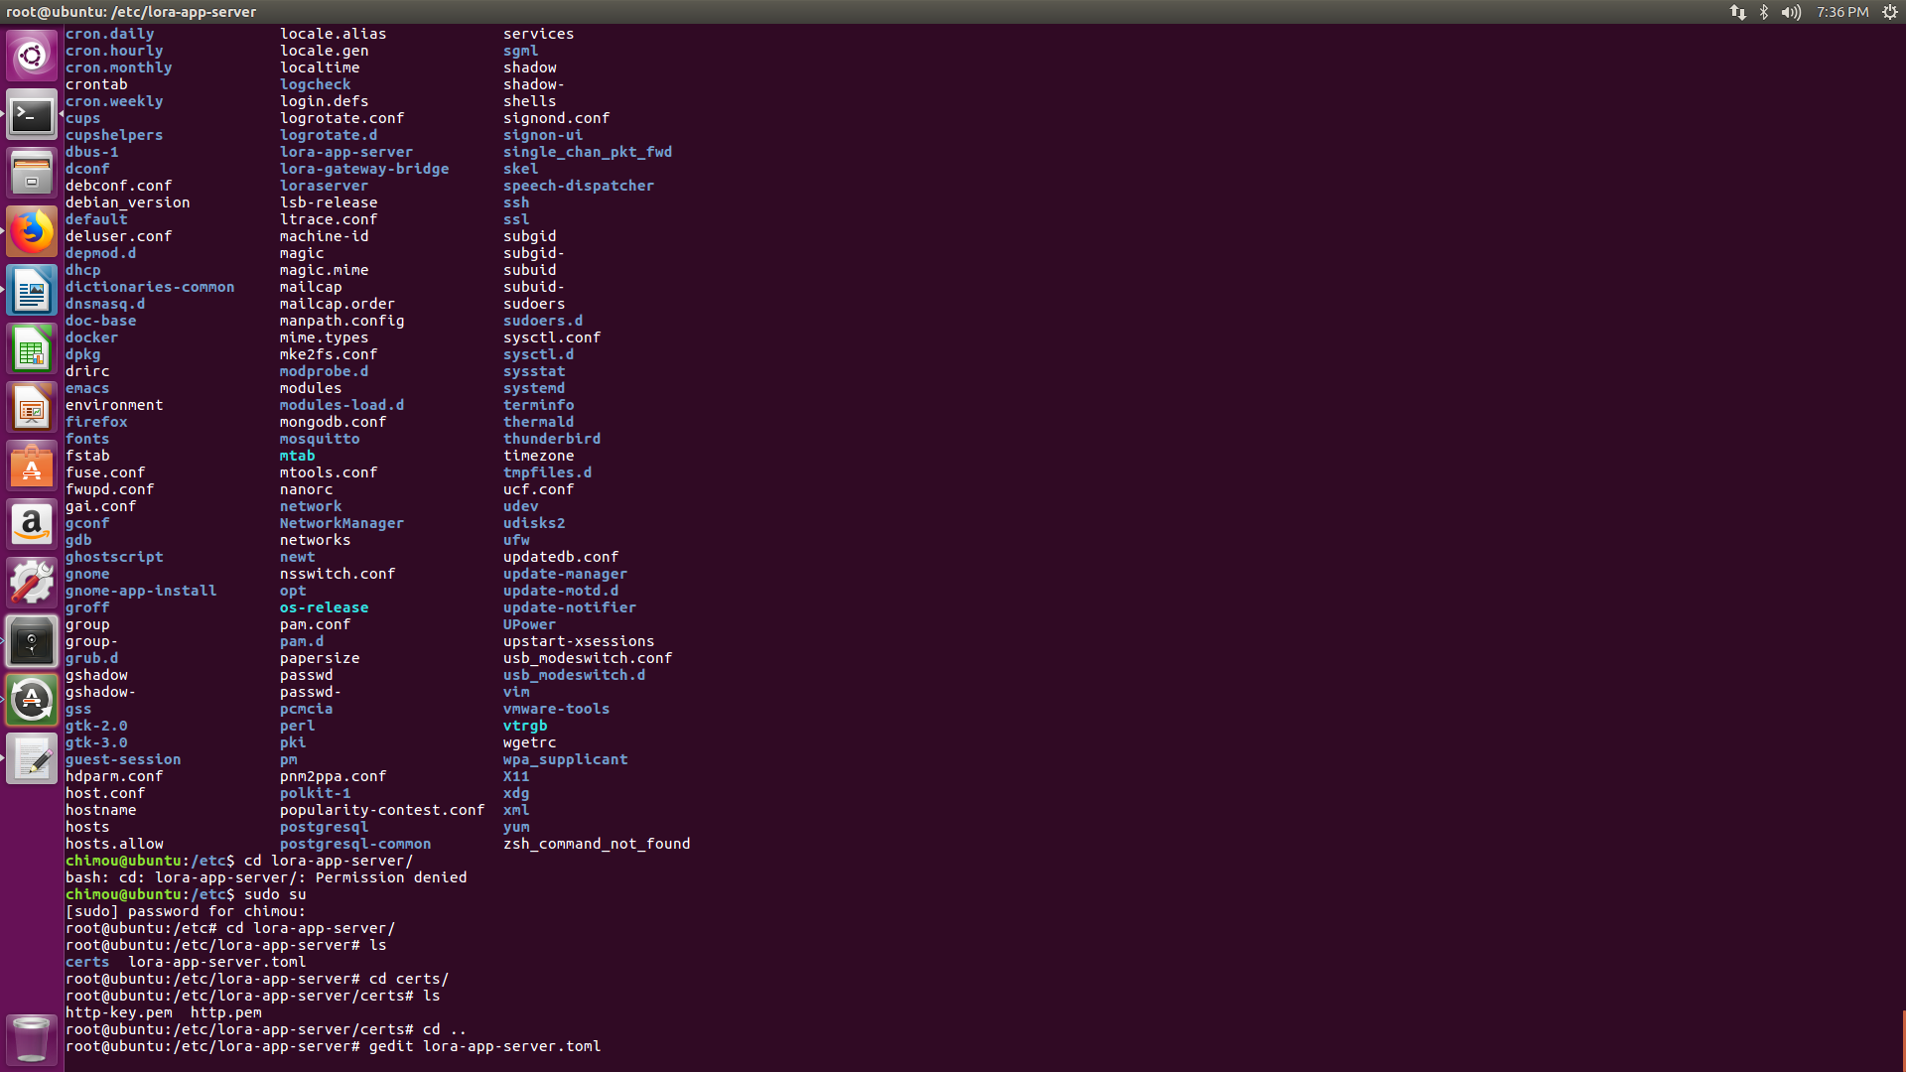

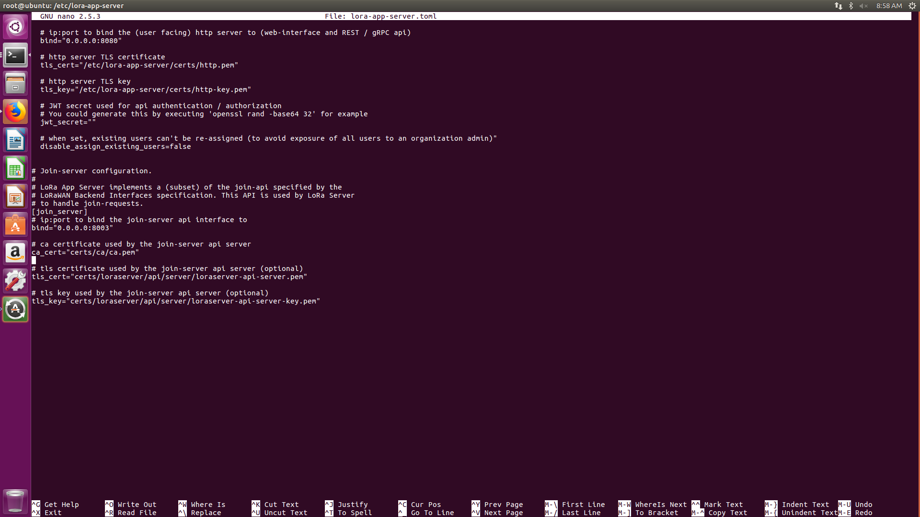

LoRa Gateway Bridge

LoRa Gateway Bridge abstracts the packet_forwarder protocol into JSON over MQTT

### **Configuration file**

lora-gateway-bridge.toml

